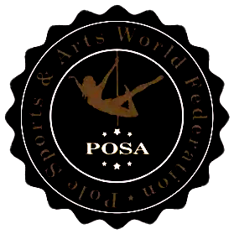

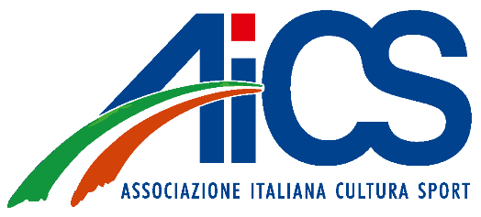

Parental Consent and Liability Acknowledgment Form
Permission to Participate in WAAC 2025 – World Artistic Aerial Championships
I, the undersigned, certify that I am the parent or legal guardian of the minor participant listed below.
I hereby authorize my minor child named below to participate in WAAC 2025 – World Artistic Aerial Championships, including all official competition, warm-up areas, training, rehearsals, and related activities.
Minor’s Full Name: ___________________________
Date of Birth: ___________________________
Parent/Legal Guardian Name: ___________________________
Address: ___________________________
Email or Phone Contact: ___________________________
I confirm that I have read, understood, and accepted the official POSA / WAAC 2025 Competition Rules. I understand that ______________________________________________________ (coach’s name) will supervise and accompany my child in all official areas of the competition.
I acknowledge and understand that participation in aerial sports carries inherent risks, including but not limited to falls, bruises, strains, or other injuries. I accept these risks on behalf of my child.
I assume responsibility for any misconduct by my child that may result in injury to themselves, injury to others, or damage to facilities or equipment due to improper use by the minor.
I understand that this acknowledgment and assumption of risk does not release the organizers, POSA, or Motus Evolution ASD from liability in case of gross negligence or willful misconduct.
By signing this form, I declare that I have been fully informed about the details of the event and that my child is physically fit and able to participate.
Parent/Legal Guardian Signature: ___________________________
Date: ___________________________
Minor’s Signature (if age ≥12): ___________________________
Date: ___________________________

