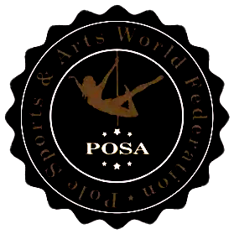

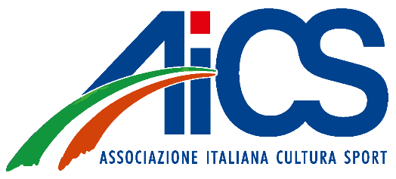

Acknowledgment and Compliance with the International Federation Code of Ethics
WAAC 2025 Cesenatico - Italy
I, the undersigned, hereby acknowledge that I have read and understood the International Federation Code of Ethics, which is publicly available at the following link: https://www.posaworld.org/the-federation/code-of-ethics/.
I agree to fully comply with its principles and provisions during all activities related to the Federation.
I understand that any violation of the Code may result in disciplinary action in accordance with the rules and regulations of the Federation.
Name: _______________________________
Signature: ____________________________
Date: ________________________________

